Elements of Short Stories

- Plot – sequence of events or incidents that make up a story.
  - Exposition – designed to arouse reader’s interest; background is provided.
  - Conflict – struggle between opposing forces (protagonist vs. antagonist)
    - Person vs. Person – external struggle between two or more individuals.
    - Person vs. themselves – internal struggle concerning emotion and decision.
    - Person vs. nature – external struggle between person and an element of nature or the environment.

  - Rising action – complication or development of the conflict.
  - Climax – turning point of the story; point of most intense interest.
  - Falling action – (denouement) events that lead to resolution.
  - Resolution – outcome of the conflict.

Parts of a Typical Plot

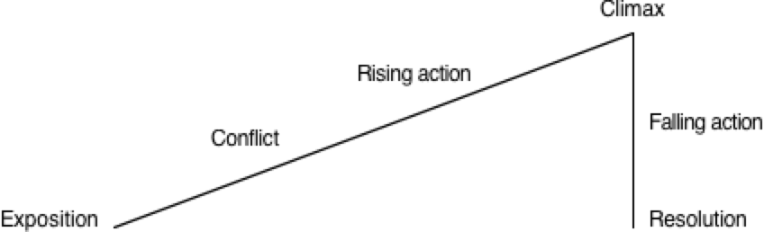

- Character – is generally the central or focal element in a story.
  - Four types of characterization – techniques the writer uses to develop a character.
    - Physical description.
    - Speech and actions of the character.
    - Direct comment from the narrator.
    - Speech and other actions of other characters.
  - Four types of characters –
    - Round – complex or presented in detail.
    - Dynamic – developing and learning in the course of the story.
    - Flat – characterized by one or two traits.
    - Static – unchanged from the story’s beginning to end.

- Themes of literature / Analyzing characters
  - Motivation – cause of / reason for actions.
  - Behavior – actions of the character.
  - Consequences – results of actions.
  - Responsibility – moral, legal, or mental accountability.
  - Expectations – what the reader expects.

- Mood
  - Setting – the time and place in which the story is taking place, including factors such as weather and social customs.
  - Atmosphere – the mood to feeling which pervades the story.

- Point of view
  - Omniscient – the author tells the story using the third person. Author knows all of what is done, said, felt, and thought by the characters.

  - Limited omniscient – author tell the story from the third person, but limits observations of thoughts and feelings to one character; the author presents the story from this character’s eyes.

  - First person – one character tells the story in the first person. The reader sees and knows only as much as the narrator.

  - Objective – the author is like a movie camera that moves around freely recording objects. However, the author offers no comments on the characters or their actions. Readers are not told the thoughts or feelings of the characters.

- Figurative language
  - Simile – comparison using like or as.
  - Metaphor – comparison using is or a form of is.
    - Implied metaphor
    - Extended metaphor
  - Personification – attributing humanlike qualities to inanimate things.

